

STUDENT NAME: CAROLINE MATHEMBO MUSYOKA
ADM NUMBER: BSCCS/2024/74753
COURSE: COMPUTER SCIENCE
UNIT CODE: BIT 3208
UNIT NAME: ADVANCED WEB DESIGN AND DEVELOPMENT
LECTURER NAME: NYORO MICHAEL
SEMESTER: MAY/AUGUST 2026
PROJECT TITLE: E-COMMERCE
SELECTED TECHNOLOGIES: PHP+MYSQL
GITHUB LINK: https://github.com/mathembocarol6-jpg/BIT3208.git

Contents
WEEK 1: LOCALHOST TESTING AND DATABASE CONNECTIVITY TESTING 4
1. INSTALLED LOCALHOST 4
Figure 1.0: XAMPP control panel 4
2. LOCALHOST TESTED SUCCESSFULLY 5
Figure 1.1: http://localhost/phpmyadmin/ 5
3. HELLO WORLD PAGE 5
Figure 1.2: HELLO WORLD Test page 5
4. BASIC DATABASE CONNECTIVITY 5
Figure 1.3.0: sample database 5
Figure 1.3.1: database connection string 6
Figure 1.3.2: successful database connection 6
WEEK 2: UI/UX AND DESIGN FOUNDATIONS 7
1. DESIGNED WIREFRAMES 7
Figure 2.0: canva design of the login page 7
2. DESIGNED GUI CONCEPTS 8
Figure 2.1: GUI design 8
3. SELECTED PROJECT THEME 8
4. CHOSEN TECHNOLOGY 8
WEEK 3: FRONTEND AND BACKEND PROGRAMMING FOUNDATION 9
1. JavaScript Basics 9
a) implemented JavaScript Basics 9
Figure 3.2: Created Form Validation 12
2. DOM Manipulation 13
Figure 3.3: successful DOM Manipulation 13
3. Introduction to PHP 14
Figure 3.4: Tested PHP Syntax 14
4. Database Connection 14
Figure 3.5: Successful Database Connection 14
WEEK 4: DYNAMIC BACKEND PROCESSING AND REAL USER INTERACTION SYSTEMS 15
1. Login form 15
Figure 4.0: login form 15
2. Form validation 16
Figure 4.1: form validator 16
3. PHP processing 17
Figure 4.2: user authentication processing 17
4. Folder structure 17
Figure 4.3: folder 17
WEEK 5: BUILDING DATA-DRIVEN SYSTEMS USING DATABASES 18
1. DATABASE CREATION 18
Figure 5.0: creating customer database 18
2. TABLE CREATION THROUGH SQL QUERIES 18
Figure 5.1: creating customer table 18
3. CRUD OPERATIONS 19
Figure 5.2.0: Create 19
Figure 5.2.1: Read 19
Figure 5.2.2: Update 19
Figure 5.2.3: Delete 19
4. REPOSITORY UPDATE 20
Figure 5.3: GITHUB Updates page 20
WEEK 6: Database Integration and CRUD Operations 20
1. Student management system 20
2. Library book management system 22
3. Employee record management system 24
WEEK7: User Authentication and Session Management 24
1. Student Portal Login System 24
2. Employee portal 26
3. Multi-user authentication system 27
a) Figure1: Database creation 27
b) Figure 2: school portal 27

WEEK 1: LOCALHOST TESTING AND DATABASE CONNECTIVITY TESTING

INSTALLED LOCALHOST

Figure 1.0: XAMPP control panel
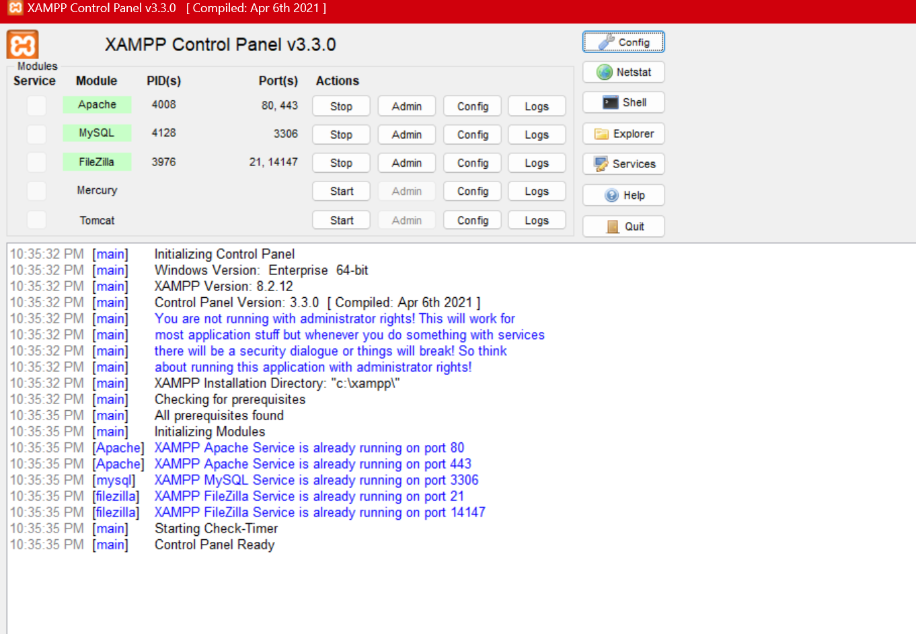

LOCALHOST TESTED SUCCESSFULLY

Figure 1.1: http://localhost/phpmyadmin/
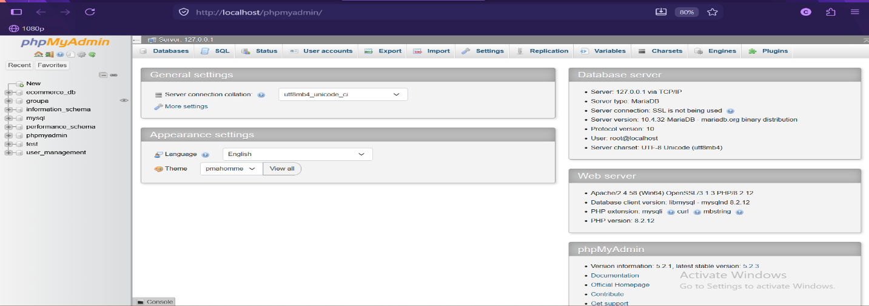

HELLO WORLD PAGE

Figure 1.2: HELLO WORLD Test page
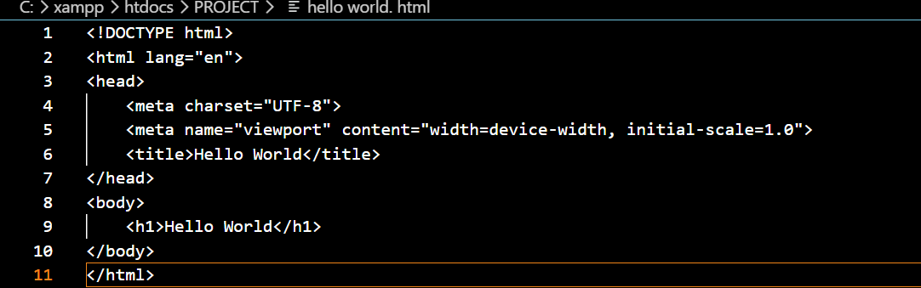


BASIC DATABASE CONNECTIVITY

Figure 1.3.0: sample database
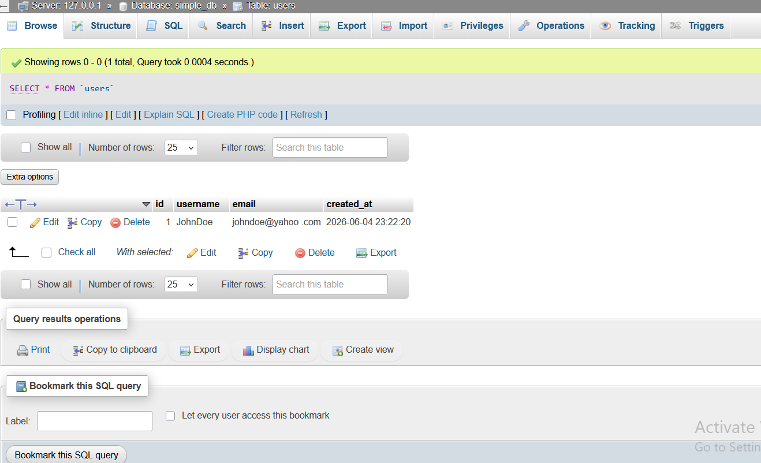

Figure 1.3.1: database connection string
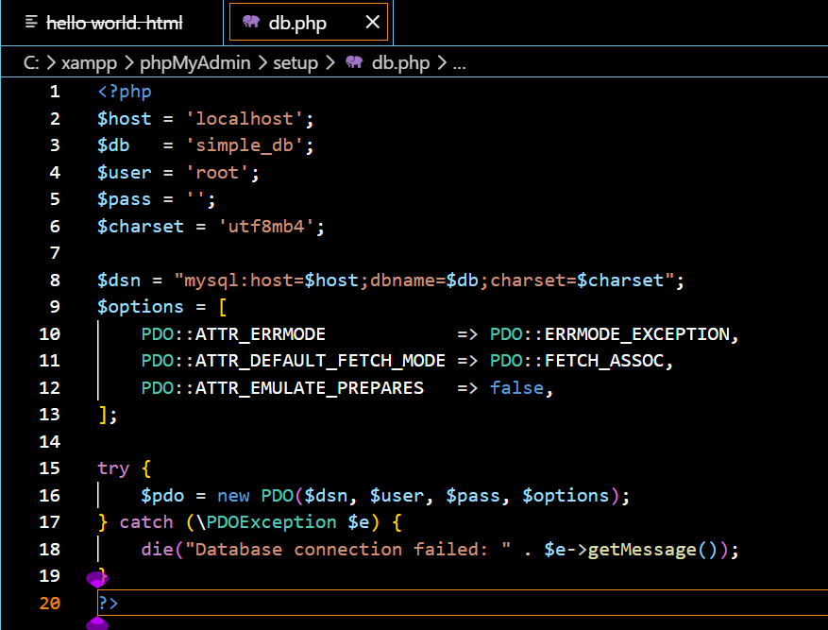

Figure 1.3.2: successful database connection
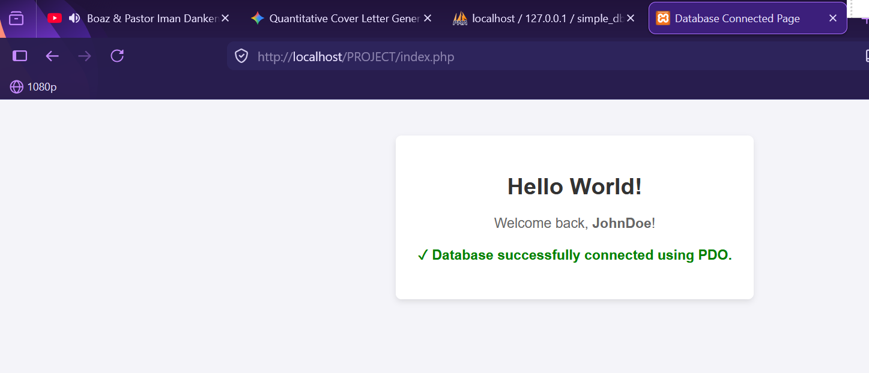

WEEK 2: UI/UX AND DESIGN FOUNDATIONS

DESIGNED WIREFRAMES

Figure 2.0: canva design of the login page
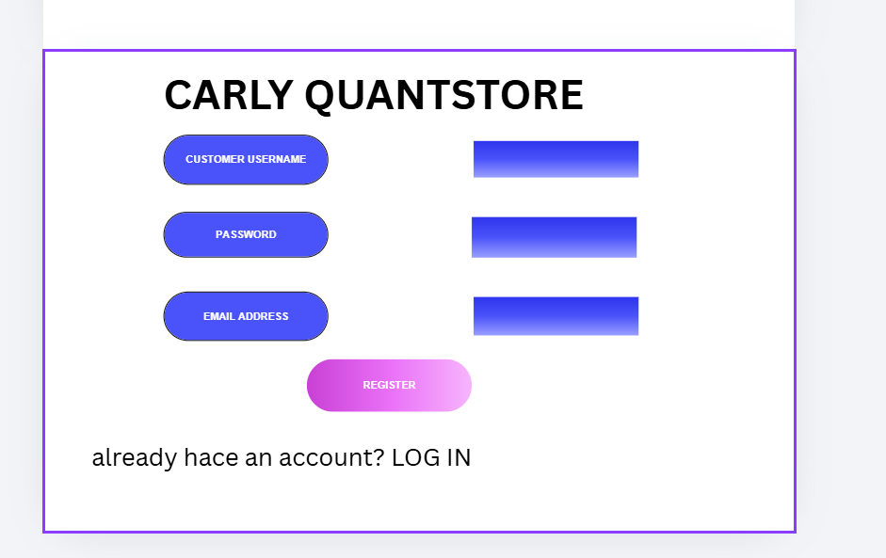

DESIGNED GUI CONCEPTS

Figure 2.1: GUI design
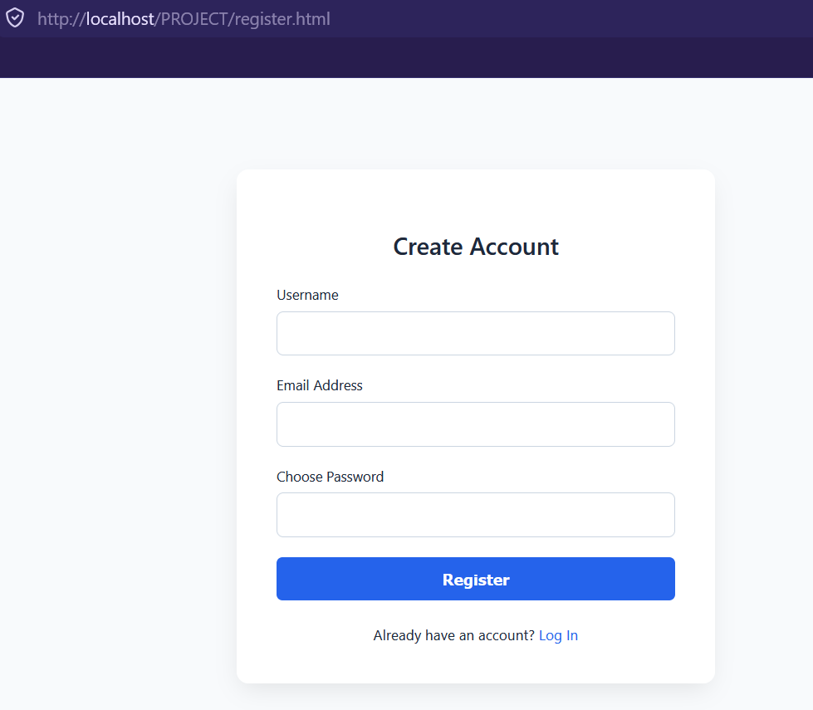

SELECTED PROJECT THEME
I have selected Digital Tech and Gadget Marketplace because tech platforms rely heavily on clean categorization and specification filtering. My MySQL can utilize a structured relational layout to handle precise product attributes. A dynamic product filtering matrix where JavaScript handles search and category filters on the client side by querying your PHP REST API asynchronously.

CHOSEN TECHNOLOGY
For my project I have used PHP, MySQL and Native JavaScript

WEEK 3: FRONTEND AND BACKEND PROGRAMMING FOUNDATION

JavaScript Basics

implemented JavaScript Basics

figure 3.1.0: user implementation
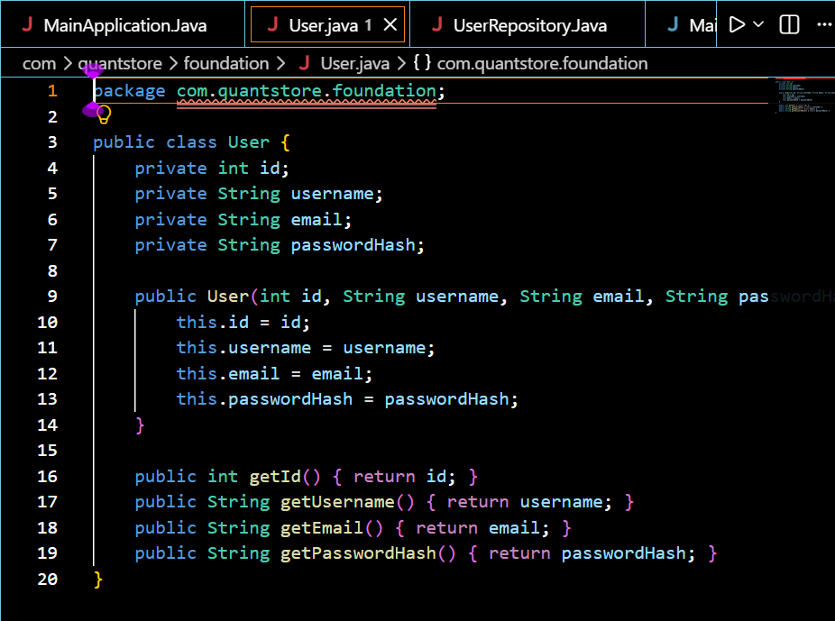

Figure 3.1.1: user repository implementation
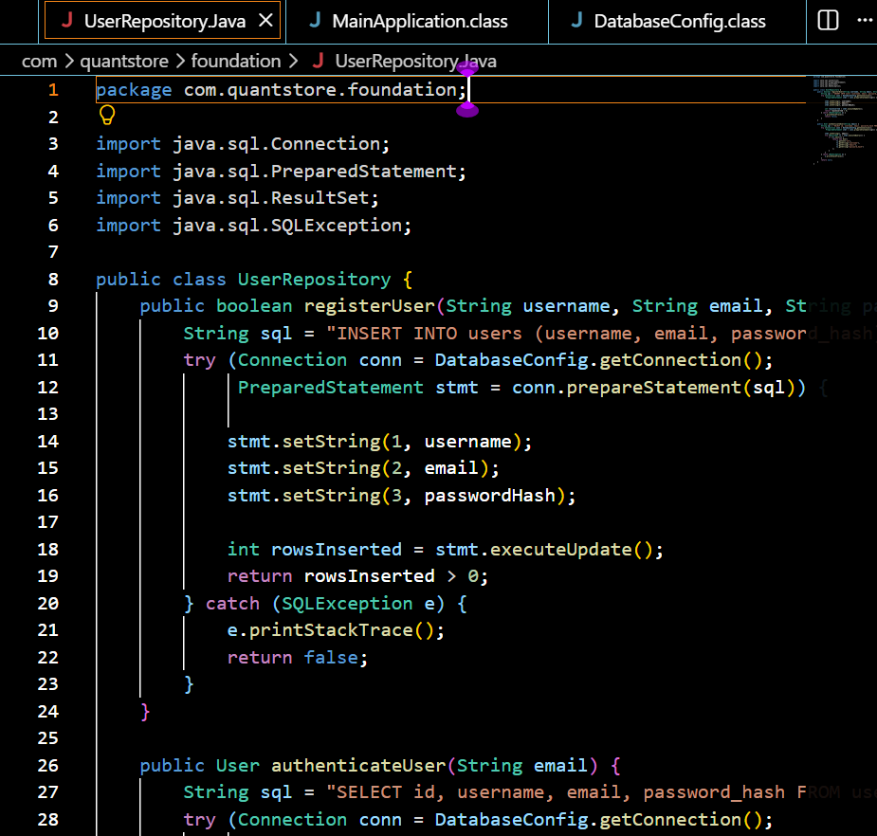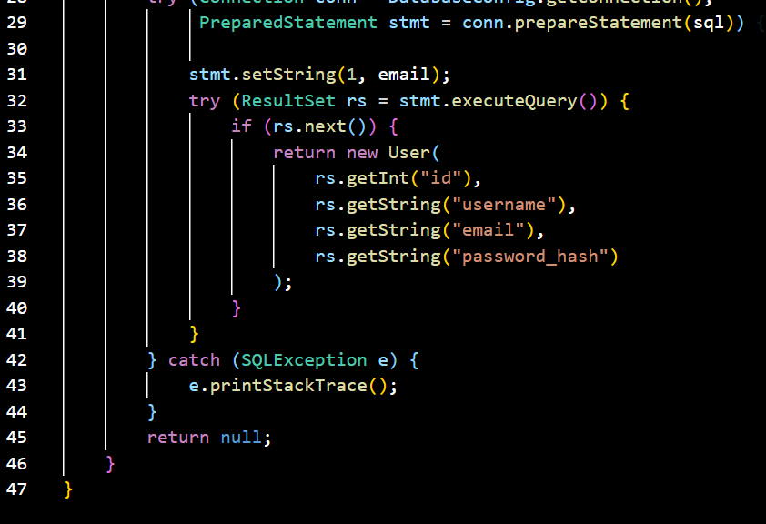

Figure 3.1.2: database configuration implementation
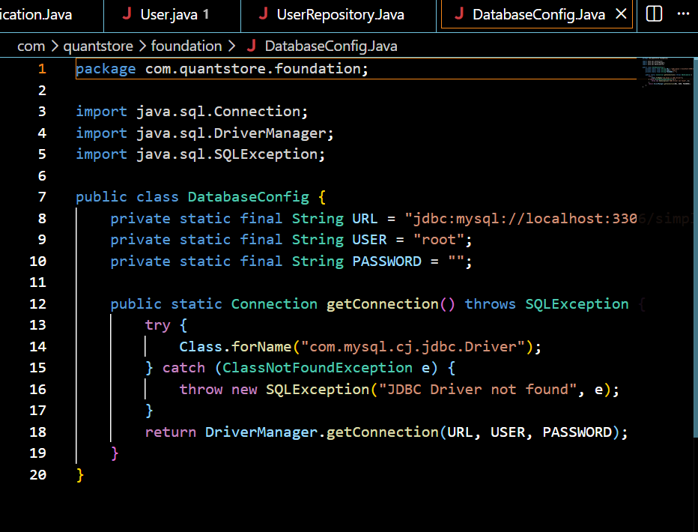

Figure3.1.3: main application java implementation
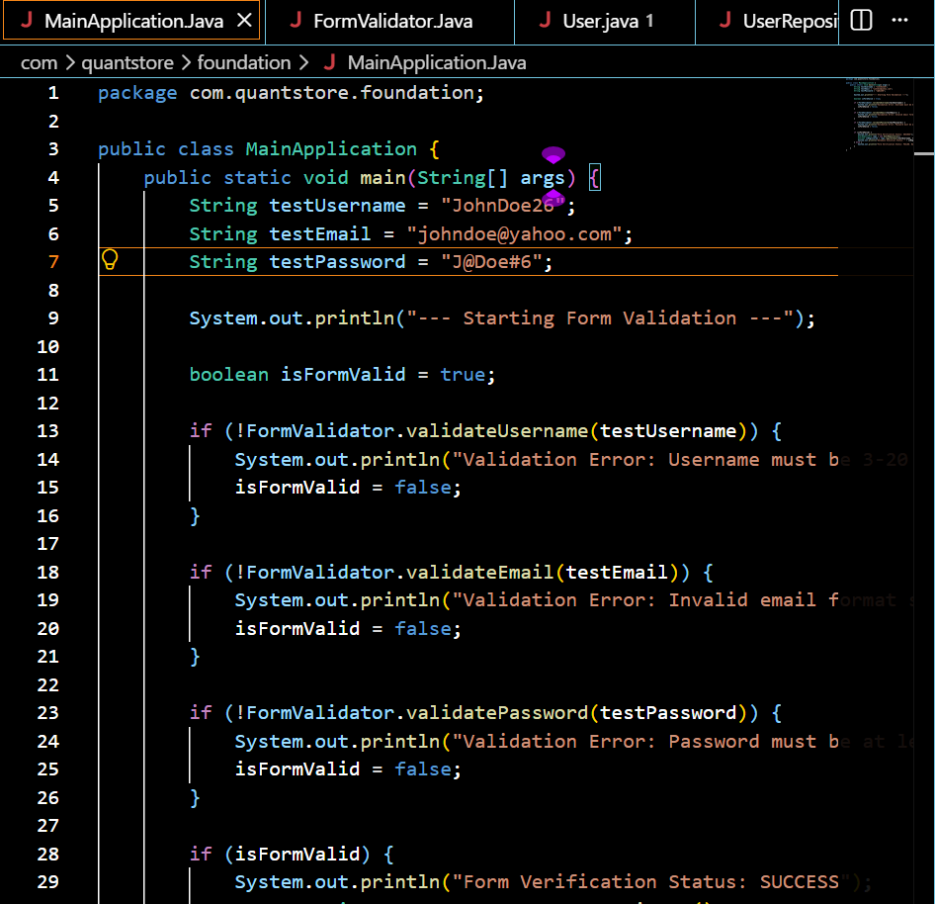
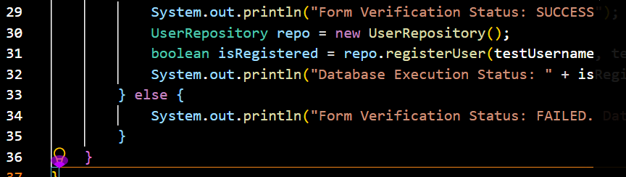

Figure 3.2: Created Form Validation
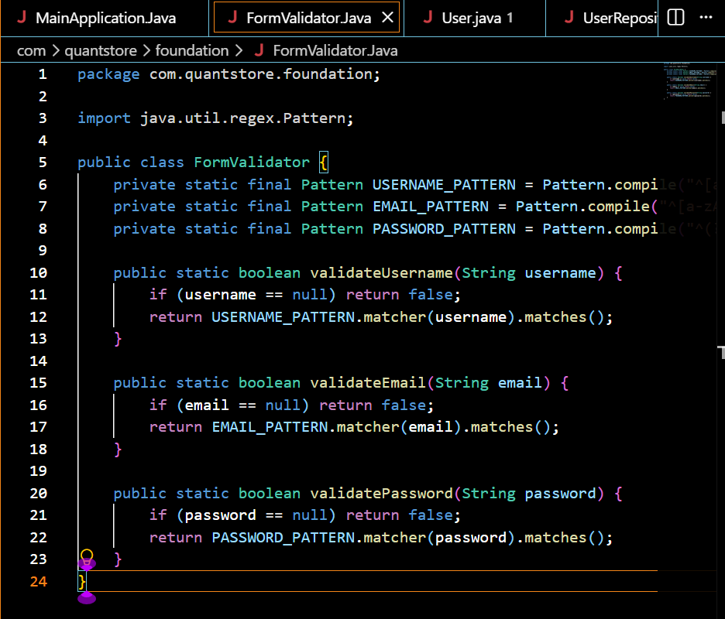

DOM Manipulation

Figure 3.3: successful DOM Manipulation
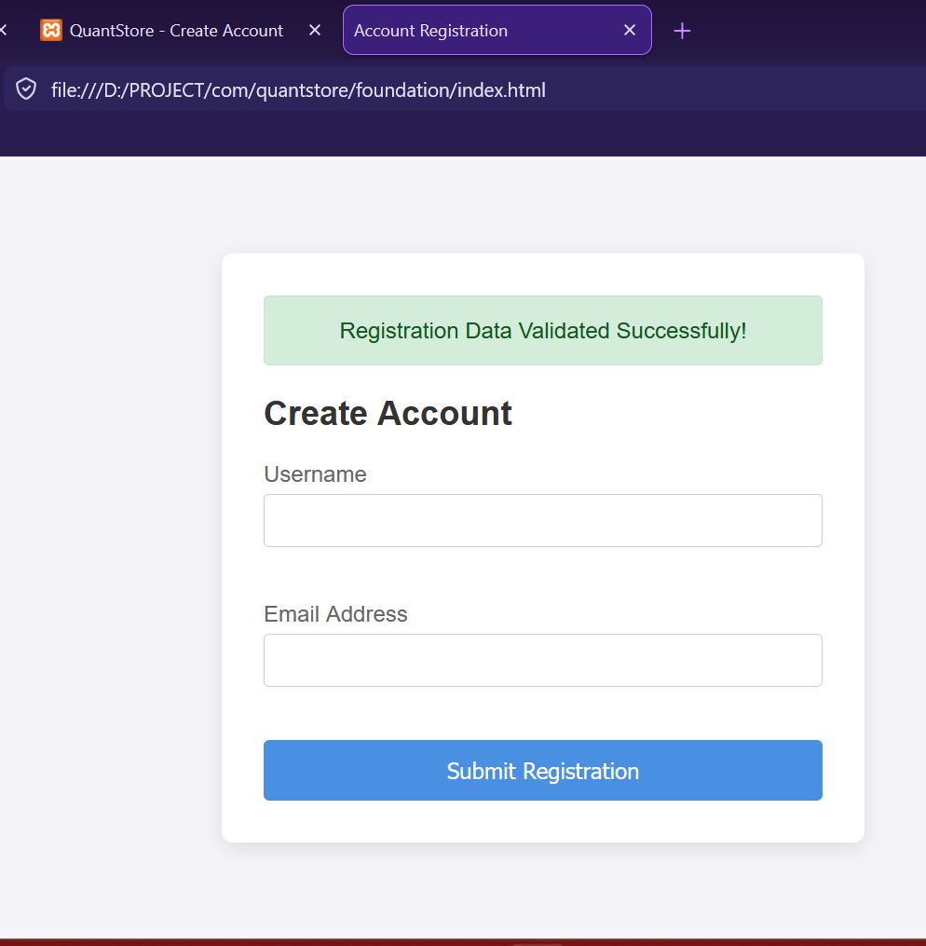

Introduction to PHP

Figure 3.4: Tested PHP Syntax
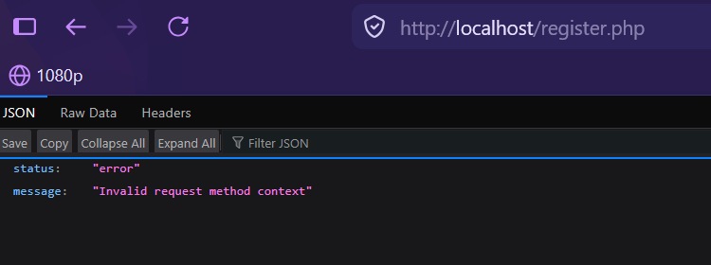

Database Connection

Figure 3.5: Successful Database Connection
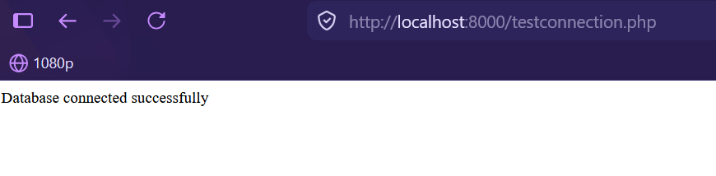

WEEK 4: DYNAMIC BACKEND PROCESSING AND REAL USER INTERACTION SYSTEMS

Login form

Figure 4.0: login form
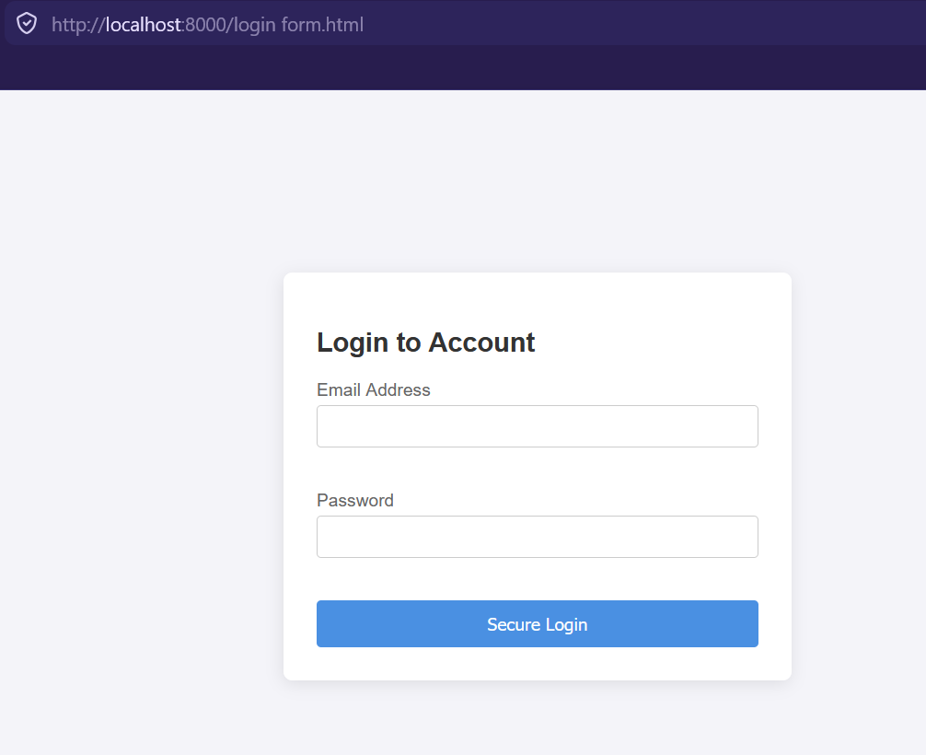

Form validation

Figure 4.1: form validator


PHP processing

Figure 4.2: user authentication processing
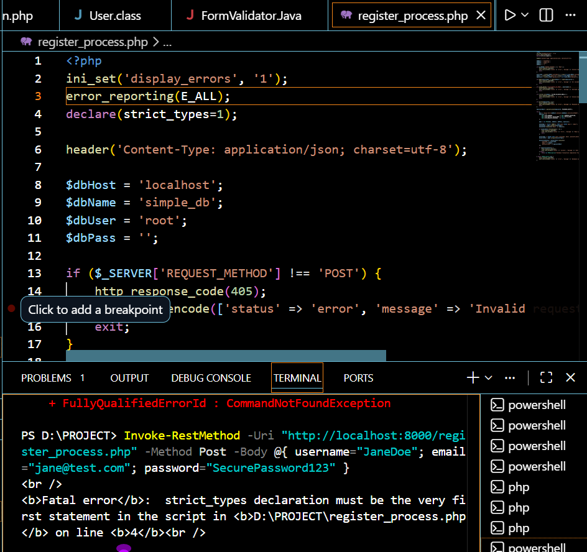

Folder structure

Figure 4.3: folder
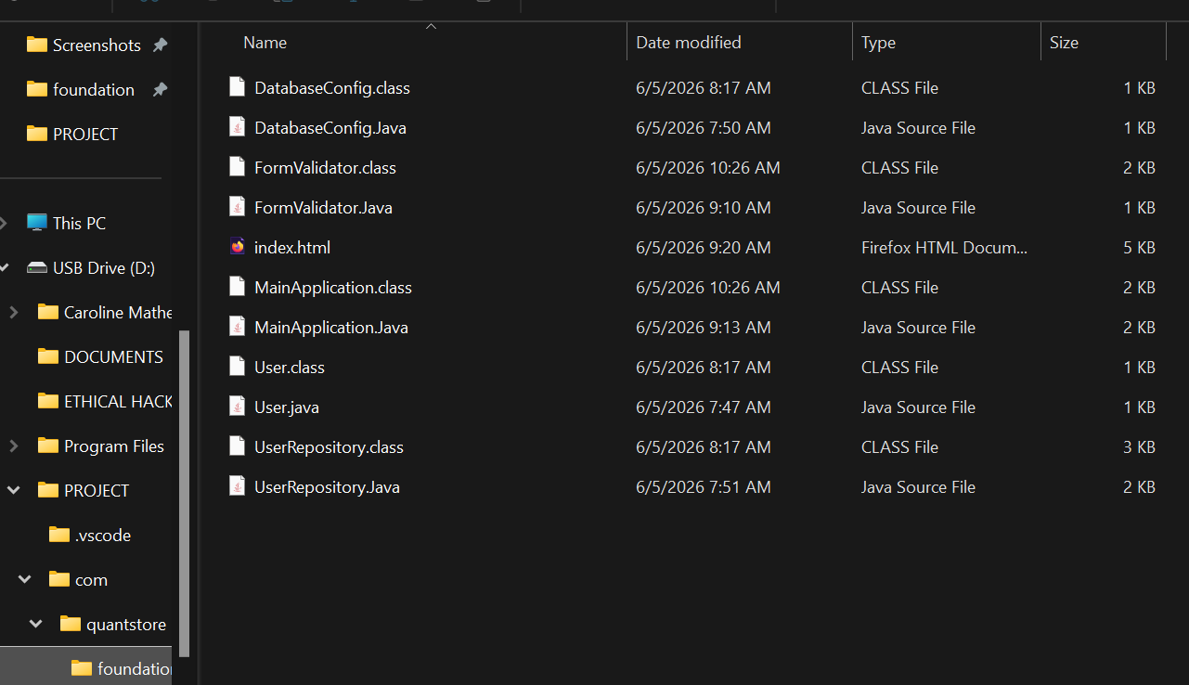

Database connection

Figure 4.4: successful database connection



WEEK 5: BUILDING DATA-DRIVEN SYSTEMS USING DATABASES

DATABASE CREATION

Figure 5.0: creating customer database
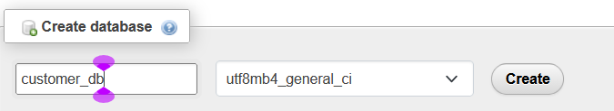

TABLE CREATION THROUGH SQL QUERIES

Figure 5.1: creating customer table
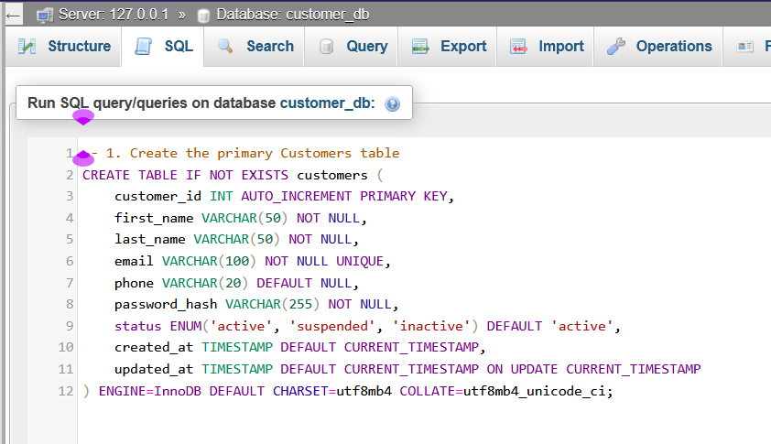
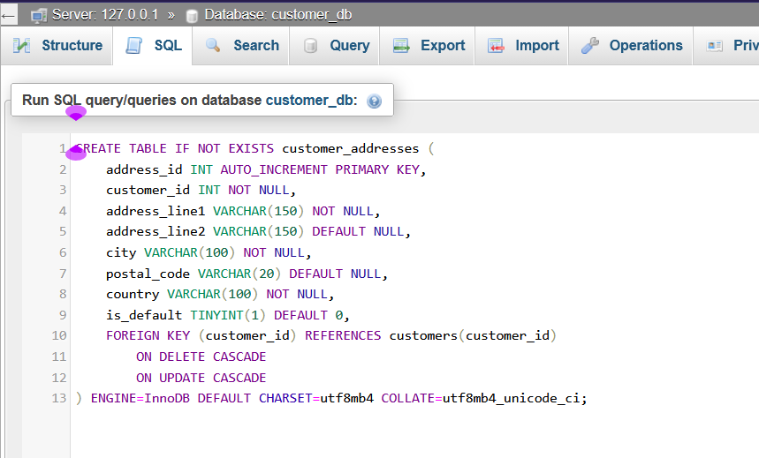

CRUD OPERATIONS

Figure 5.2.0: Create
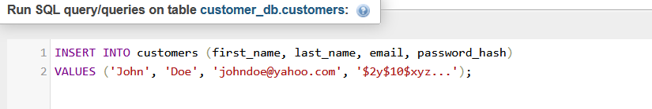

Figure 5.2.1: Read
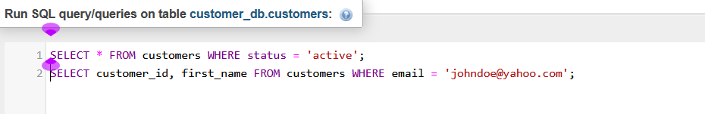

Figure 5.2.2: Update
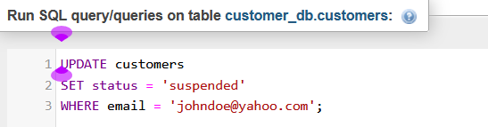

Figure 5.2.3: Delete
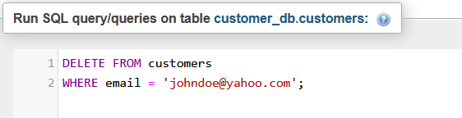
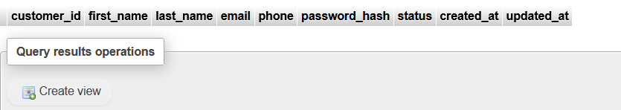

REPOSITORY UPDATE

Figure 5.3: GITHUB Updates page
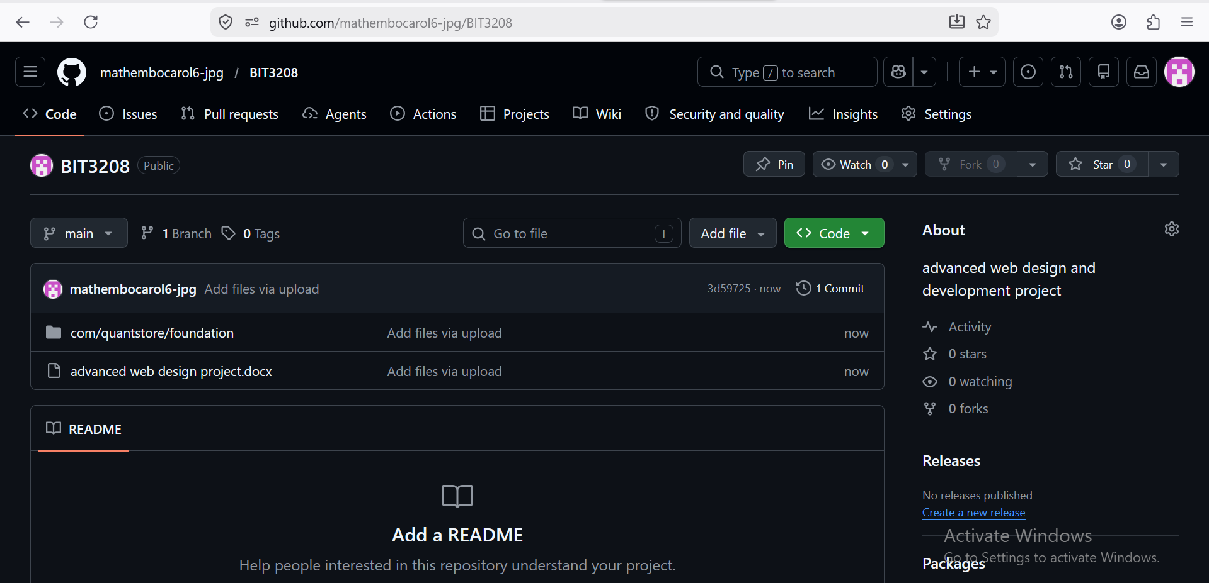

WEEK 6: Database Integration and CRUD Operations

Student management system
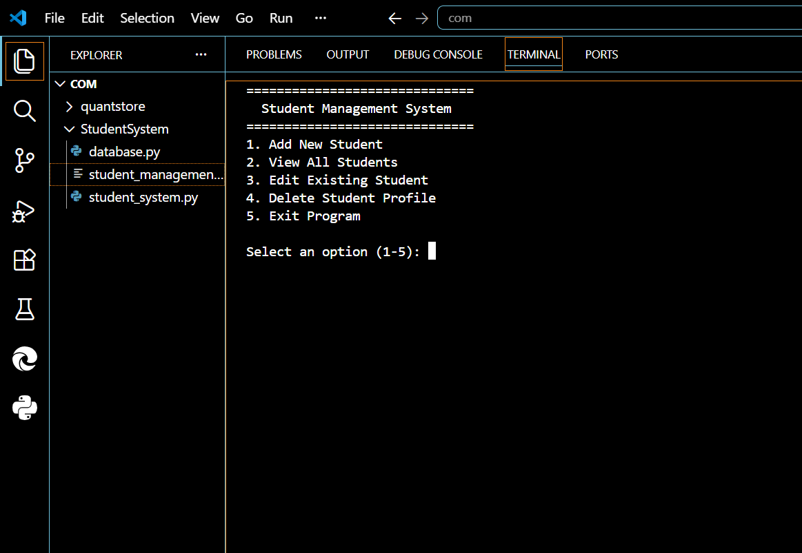
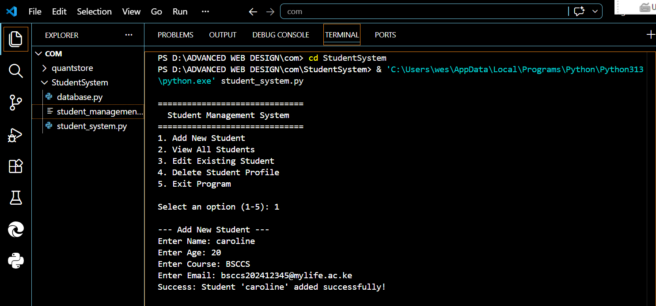
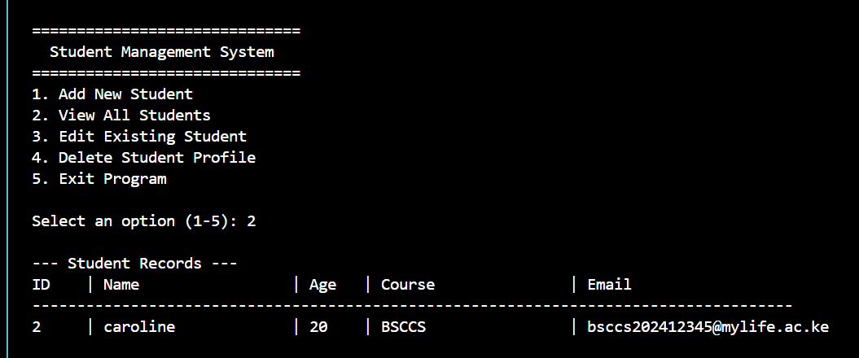
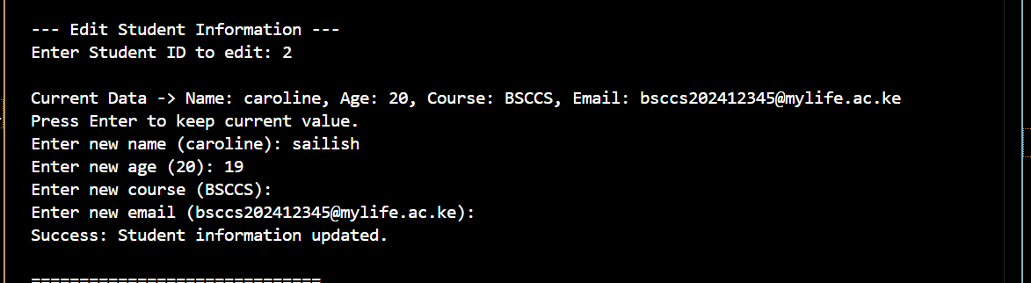
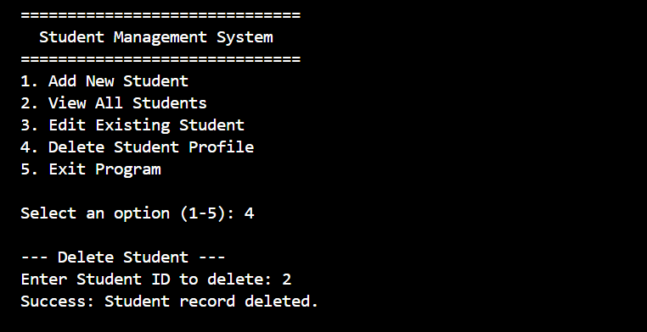
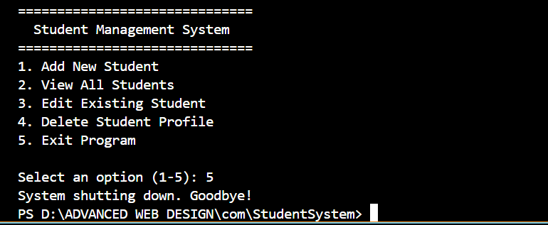

Library book management system

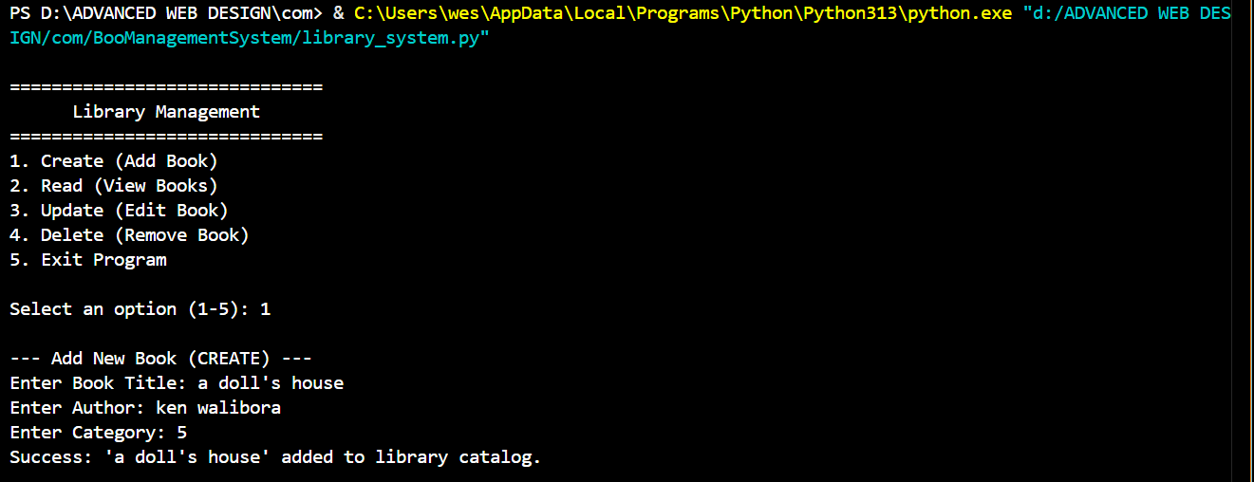
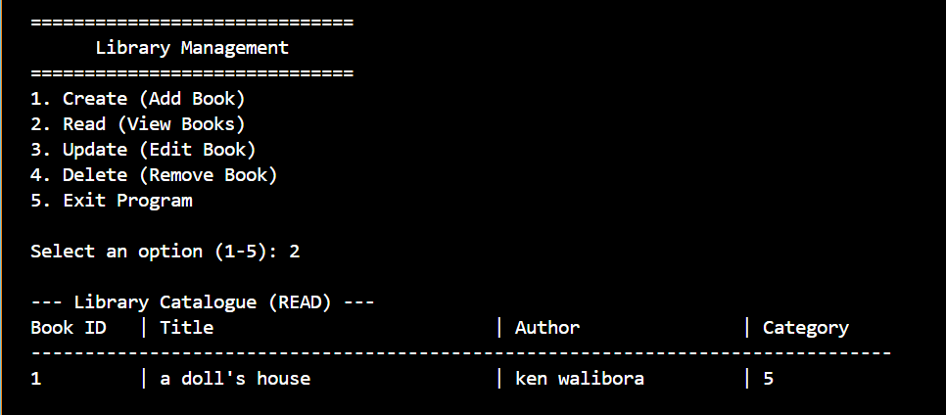
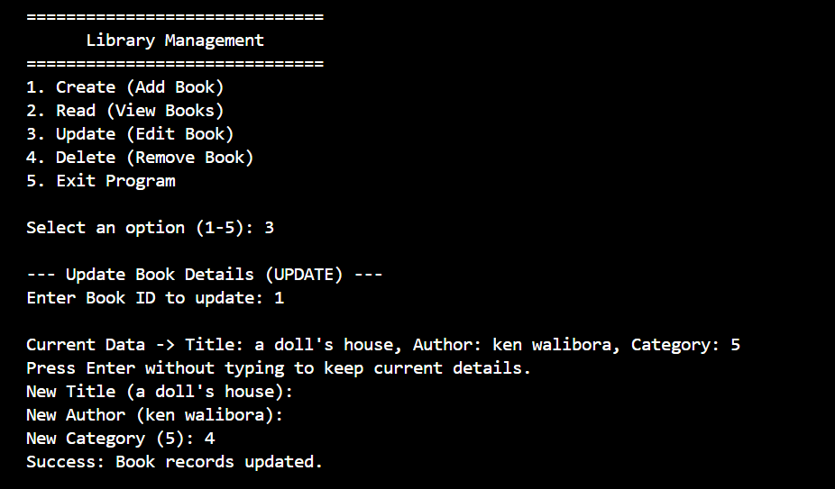
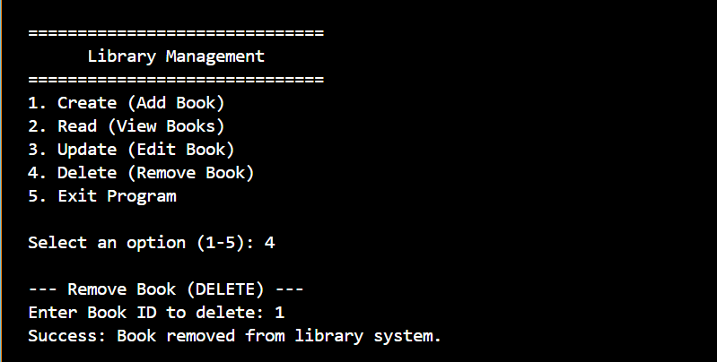
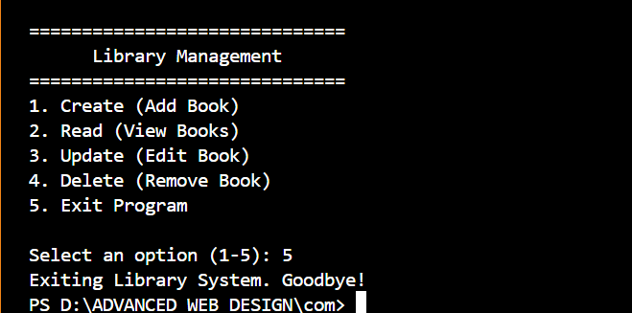

Employee record management system
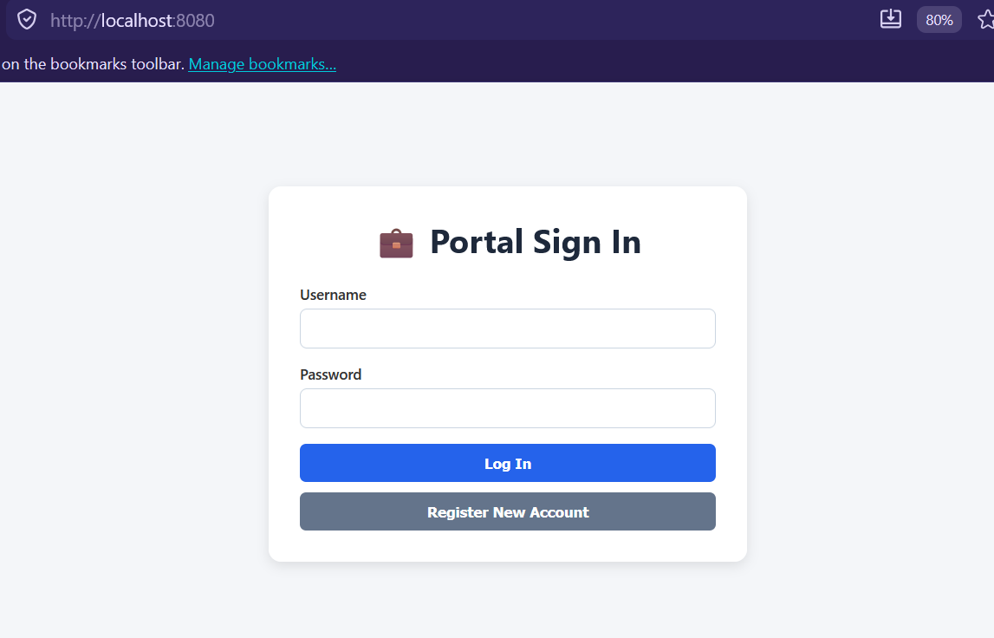
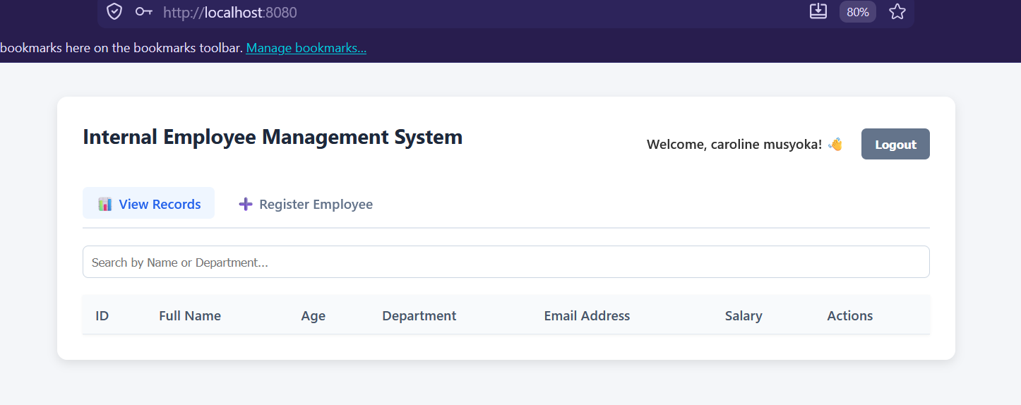

WEEK7: User Authentication and Session Management

Student Portal Login System
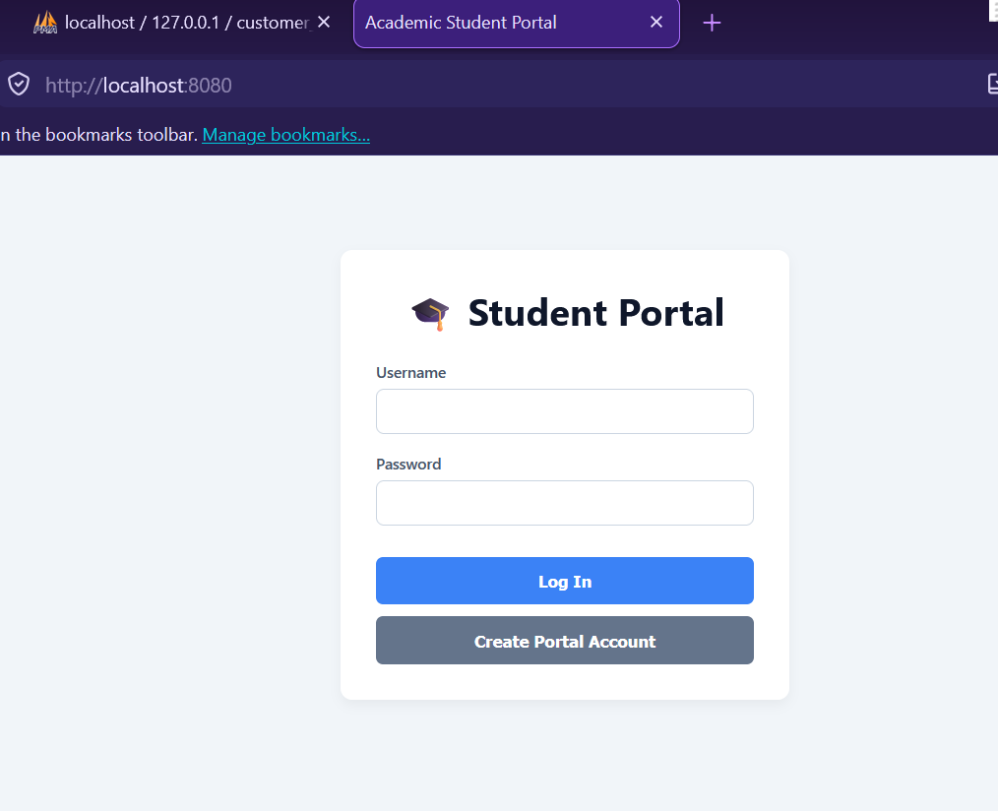
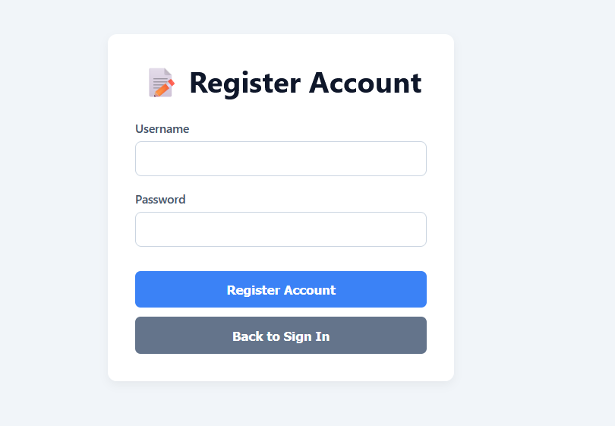
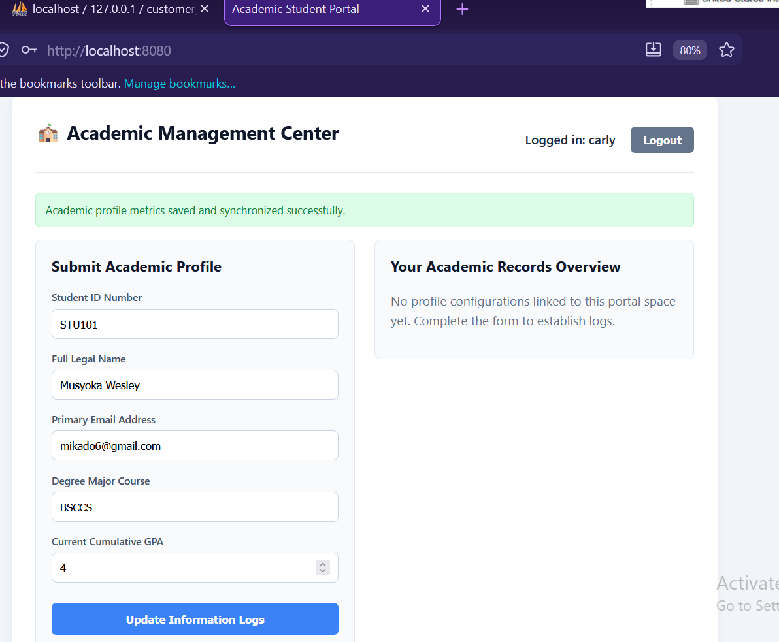

Employee portal
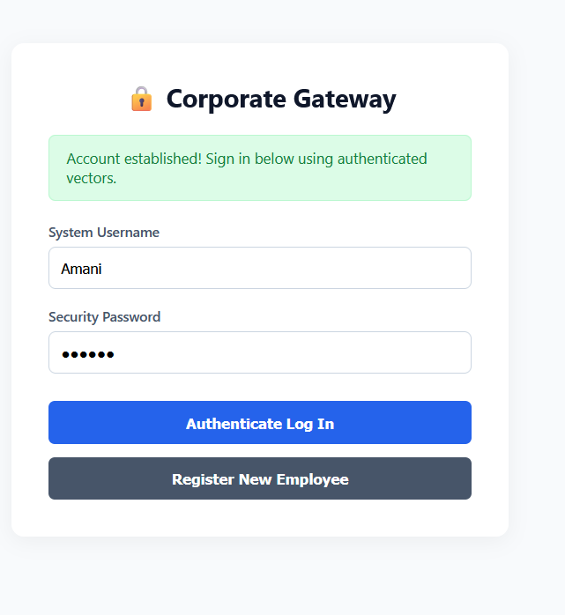
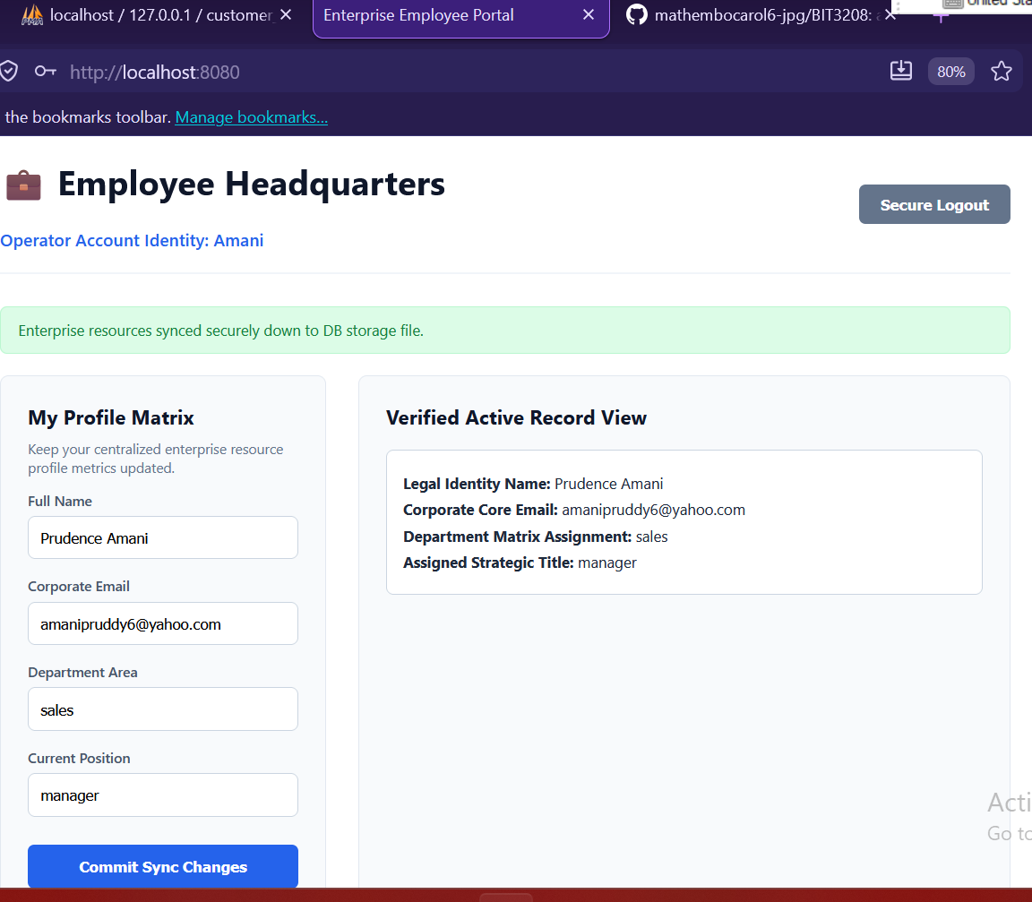

Multi-user authentication system

Figure1: Database creation
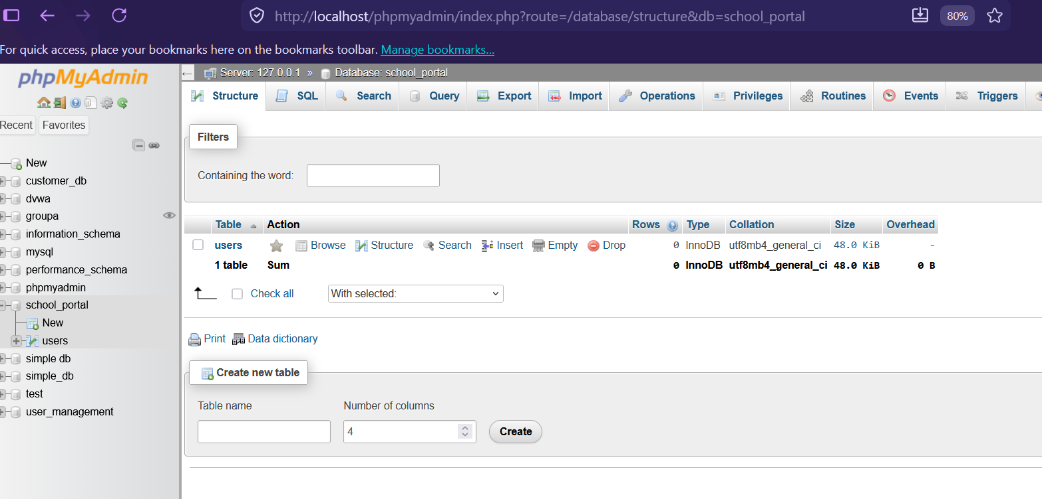

Figure 2: school portal
